**Memorandum**

DATE: 30 January 2017

TO: Rich Marovich, Roland Sanford, and Chris Lee, Solano County Water

Agency (SCWA)

FROM: Tim Salamunovich, Normandeau Associates

RE: Results of October 2016 lower Putah Creek fish surveys

Normandeau Associates Arcata Office staff has been sampling the fish fauna of lower Putah Creek using tote barge electrofishing since August 1991. Students from the University of California at Davis (UCD) have been regularly sampling the creek near campus using a combination of boat/backpack electrofishing, seining, and gill netting each fall since 1978. Following the May 2000 Putah Creek Accord, Normandeau continued surveying multiple sites along the creek each October as part of an annual fish monitoring program under the aegis of the Lower Putah Creek Coordinating Committee. A database containing all the raw data (individual fish lengths and weight data by site and survey date) for the entire period of record is regularly updated and managed by SCWA. The data through 2008 was treated in a scientific publication that demonstrated the recovery of native fishes in the upper 12.5 miles of the creek (upstream of Pedrick Road [County Road 98]) following the native fish rearing and spawning flows instituted under the Accord (Kiernan et al. 2012).

Part of the Accord required releases of late fall supplemental flows to attract anadromous fish into lower Putah Creek to spawn. The estimated Chinook spawner abundance of 700 salmon for 2015 (Davis 2016a) was 3-4 times higher than the estimates for fall 2014 that were about 200 fish (Davis 2015) and 20-30 times higher than the periodic and intermittent runs noted prior to 2014, which have typically been estimated in the 20-40 fish per year, when they have occurred. Recent habitat improvements in lower Putah Creek, including channel modifications to increase shallow-water habitat and improve functional floodplains and side channel, spawning gravel enhancement, erosion control, invasive weed control, native vegetation enhancement, and trash removal efforts have improved spawning and rearing habitats in lower Putah Creek. Juvenile salmon typically emigrate to the ocean within a few months of hatching and emergence (Moyle 2002), however, in Putah Creek some juveniles have been observed to over-summer in the cold-water areas below the Putah Diversion Dam (Davis 2016b).

Normandeau crews sampled nine sites along 19 miles of the lower creek between Putah Diversion Dam (PDD) and Mace Boulevard (County Road 104; Figure 1) on 18-20 October 2016. Two additional sites near the UCD campus (Figure 1) were sampled on 15 October 2016 by a UCD fisheries class and the results were generously provided for review. This memo report will present the results of these two most recent sampling efforts.

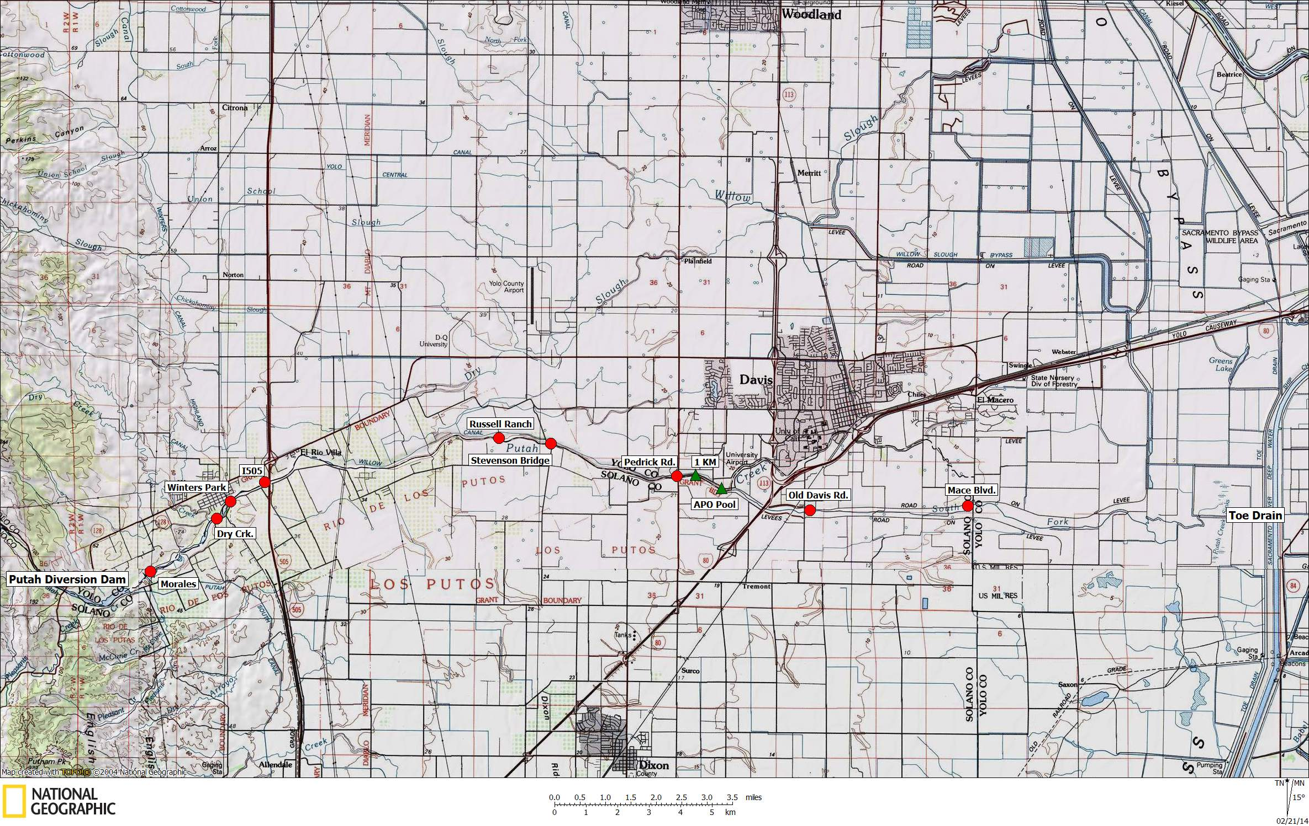

Figure 1. Map showing the nine Normandeau sample sites (red circles) and two UCD sample sites (green triangles) surveyed along

lower Putah Creek in October 2015.

The objective of the electrofishing survey was to determine the distribution and relative abundance of fish populations in lower Putah Creek. Normandeau crews captured fish using a Smith-Root gas powered generator and pulsator (model 2.5 GPP) operated out of a small pram. Two biologists wading alongside the pram used electrofishing probes to attract and stun fish. Two additional biologists netted and captured stunned fish and transferred them to buckets located in the front of the pram. A fifth person rowed or pulled the pram and was primarily responsible for shutting off the electric current in the event of a mishap. Sampling effort was emphasized along the margins of the creek around instream cover and overhead vegetation, but additional effort was still allocated to open water portions of the creek. Total effort expended at each site was made approximately equal by a combination of measurements of stream area and shocking seconds. All stunned fish were netted and held in 5-gallon buckets of creek water equipped with small bait-bucket aerators and captured fish were periodically transferred to a live cart until the completion of sampling, at which time the fish were identified and measured to nearest millimeter using either fork length (FL) or total length (TL). A sub-sample of the catch was also weighed to nearest 0.1 gram to determine condition factors (length-weight ratios) prior to release. All rainbow trout captured during the surveys were weighed to evaluate condition factor. The trout were anesthetized in weak CO2 solution prior to handling to reduce movement and injury during the measurement and weighing process. After handling, all trout were allowed to recover in an aeration bucket until fully mobile prior to their release back into the creek.

Two additional sites (the Alpha Phi Omega [APO] pool and the 1 Kilometer [1 KM] sites) were sampled by students of the UCD Wildlife, Fish, & Conservation Biology class on 15 October 2016 (Figure 1). UCD sampling used a variety of capture gear including beach seines, gillnets, minnow traps and a boat shocker (equipped with a 5.0 GPP) at the APO Site; and backpack electrofishers at the 1 KM Site. All fish were identified, enumerated, and most were measured to standard length (SL) and released.

The 2015 Water Year, which ended three weeks prior to the sampling, has not yet been given final regional classifications, but according to the most recent available data it will likely be classified as a below normal water year for the Sacramento basin according the Sacramento Valley 40-30-30 Hydrologic Classification Index (DWR California Data Exchange Center, Water Supply Index 01/10/17 1254). If the below normal designation holds, then nine of the last ten water years in the Sacramento Valley have been classified as below normal, dry, or critical. Mean daily flows in lower Putah Creek (as measured at the Putah Diversion Dam release) during the period of fish spawning and rearing for the year prior to sampling is shown in Figure 2.

Similar to the past several years, there were no extended periods of high flows during the 2016 water year (Table 1). The maximum daily flow for the water year immediately prior to sampling was 470 cfs cubic feet per second (cfs) and was the result of early March storm event. The remaining short duration peak flow events were the result of two other winter storms. The other flow events were the result of managed releases into the lower creek to accommodate salmon migration in the late fall 2015 and native fish spawning in the early spring 2016. Despite the below normal water year, the mean dam release to the lower creek for the 2016 Water Year was 55.7 cfs, and the dam release never fell below 25 cfs during the water year.



Figure 2. Mean daily discharge released into lower Putah Creek at the Putah Diversion

Dam during the 2016 Water Year.

Table 1. Number of days that mean daily releases from Putah Diversion Dam exceeded

certain values during the 2016 water year (1 October 2015–30 September

2016). Data from USBR Mid-Pacific Region, Central Valley Operations Website.

|  |  |
| --- | --- |
| Exceedance (cubic feet per second) | Number of Days |
|  |  |
| ≥ 500 cfs | 0 |
| ≥ 400 cfs | 3 |
| ≥ 250 cfs | 7 |
| ≥ 200 cfs | 7 |
| ≥ 150 cfs | 10 |
| ≥ 100 cfs | 11 |
| ≥ 50 cfs | 117 |
| ≥ 25 cfs | 366 |

As specified in the Accord, flows in Putah Creek at Interstate 80 Bridge near Davis are monitored and dam releases to lower creek are adjusted to maintain minimum flows of at least 5 cfs (or higher) at that location throughout the year (Table 2). This flow requirement ensures maintenance of a live stream throughout 15.5 miles of the lower basin, even during dry and critically dry water years. In addition, the Accord includes supplemental flow releases into the lower basin to attract anadromous salmonids in the fall and to promote native fish spawning in the spring (Figure 2).

Table 2. Mean daily flow requirements for Putah Creek at Interstate 80.

|  |  |
| --- | --- |
| Month | Minimum Flow Requirement (cfs) |
|  |  |
| October | 5 |
| November | 10 |
| December | 10 |
| January | 15 |
| February | 15 |
| March | 25 |
| April | 30 |
| May | 20 |
| June | 15 |
| July | 15 |
| August | 10 |
| September | 5 |

Stream flow in the lower basin during the October 2016 Normandeau and UCD fish surveys survey varied by site and ranged from 29 cfs at the Putah Diversion Dam to about 8 cfs at the sites downstream of the I-80 Bridge (Table 3).

Water temperatures measured during the October surveys varied by site as a function of both the time of day and the distance downstream of the Putah Diversion Dam release point (Table 3). The temperatures ranged from 14.4° to 18.2°C (57.9° to 64.8°F). Water conductivity (a measure of total dissolved solids) did not vary in the upper 13 miles of the project area, then remained higher (but stable) in the lower six miles downstream of the Pedrick Road Site. Except for the most downstream Mace Boulevard site, dissolved oxygen levels were relatively high and were at or exceeded 8 mg/L at the remaining sites sampled. No water quality data was recorded at the 1 KM Site during the UC Davis surveys.

Table 3. River mile location, sample date, survey time, stream flow, water temperature,

conductivity, and salinity at time of survey for the eleven lower Putah Creek

study sites during the October 2015 fish monitoring surveys. River mile

notation is based upon USBR convention where RM 0.0 is point where creek

enters the Yolo Bypass.

|  |  |  |  |  |  |  |  |  |
| --- | --- | --- | --- | --- | --- | --- | --- | --- |
| Site | River Mile | Date | Time | Flow 1/  (cfs) | Temp (°C) | DO (mg/L) | Cond  (μS/cm) | Salinity  (ppt) |
|  |  |  |  |  |  |  |  |  |
| Putah Diversion Dam | 22.6 | 10/20/16 | 1330 | 29.0 | 15.5 | 11.27 | 301 | 0.2 |
| Dry Creek confluence | 20.3 | 10/20/16 | 0945 | 28.5 | 14.4 | 9.87 | 292 | 0.2 |
| Winters Park (upper weir) | 19.7 | 10/20/16 | 1130 | 27.8 | 14.7 | 10.30 | 294 | 0.2 |
| Winters Park (lower weir) | 19.7 | 10/19/16 | 1655 | 27.8 | 16.1 | 9.75 | 301 | 0.2 |
| Interstate 505 Bridge (I505) | 18.9 | 10/19/16 | 1543 | 18.0 | 15.7 | 9.44 | 298 | 0.2 |
| Russell Ranch | 13.7 | 10/19/16 | 1210 | 12.0 | 14.7 | 8.97 | 286 | 0.2 |
| Stevenson Road Bridge | 12.8 | 10/19/16 | 0927 | 12.2 | 14.0 | 8.42 | 283 | 0.2 |
| Pedrick Road Bridge | 9.9 | 10/18/16 | 1448 | 7.8 | 16.5 | 8.73 | 302 | 0.2 |
| 1 Kilometer Site (1 KM) | 9.4 | 10/15/16 | 1100 | 7.8 | --- | --- | --- | --- |
| Alpha Phi Omega (APO) Pool | 9.1 | 10/15/16 | 1030 | 7.8 | 16.9 | 9.40 | 410 | --- |
| Old Davis Road Bridge | 7.2 | 10/18/16 | 1220 | 7.7 | 16.4 | 7.97 | 420 | 0.2 |
| Mace Boulevard Bridge | 3.8 | 10/18/16 | 0950 | 7.6 | 18.2 | 5.02 | 413 | 0.2 |

1/ Flow data from Solano County Water Agency

The October 2016 fish surveys of eleven lower Putah Creek sites captured a total of 2,893 fish representing 23 species (Table 4). Sacramento pikeminnow (*Ptychocheilus grandis*) was the most abundant species, making up almost 25 percent of the total catch. The next most common fish among the catch was largemouth bass (*Micropterus salmoides*), which made up just under 20 percent of the total captures, followed by tule perch (*Hysterocarpus traskii*) and Sacramento sucker (*Catostomus occidentalis*), which contributed about 12 percent and 11 percent, respectively. Bluegill (*Lepomis macrochirus*) and riffle sculpin (*Cottus gulosus*) and each made up another 7 to 8 percent of the total fish captured. None of the remaining eighteen species made up more than four percent of the total catch, with eleven of those species each contributing less than one percent.

Of the total fish captured in the October 2016 survey, 62.7 percent (1,815 fish from 10 species) were native, or endemic Sacramento River basin fish, while 28.4 percent (1,078 fish from 13 species) were non-native, or exotic fishes (Table 4, Figure 3). The overall spatial distribution of fishes from the October 2016 survey remains similar to recent surveys and continues to demonstrate that lower Putah Creek supports a highly diverse fish fauna. The results also show that, despite five consecutive below normal water years, including some of the driest and warmest reginal conditions on record (DWR 2016) and the lack of extended periods of high flows in the lower Putah basin over this period, native fish continue to dominate the 12.7 miles of the lower basin between the Putah Diversion Dam at Winters and the Pedrick Road Bridge Site near Davis (Table 4; Figures 3 and 4).

Table 4. Capture data for the October 2016 fish monitoring surveys on lower Putah Creek.





Figure 3. Number of native and exotic fish captured at each of the lower Putah Creek study sites

during the October 2016 fish surveys.



Figure 4. Percentage of native and exotic fish captured at each of the lower Putah Creek study

sites during the October 2016 fish surveys.

Despite the relative stability of the local fish populations over the past five years of drought conditions, the recent data does indicate a gradual increase in the numbers and percentage of non-native fish at the Pedrick and 1KM sites (Figure 5). These two sites are at the interface where the native/exotic species meet and interact. Largemouth bass, a warmer water exotic species, were more abundant at the PDD and I505 sites in October 2016 compared to recent previous fall surveys too. The recent shift toward exotic species at the boundary sites and inroads of exotic species at upstream sites may be a natural population dynamic response to the climatic and hydrologic conditions that have occurred in the basin over the past few years. If this is the case, this change in native/exotic fish relationship may continue to change in favor of the non-native warm water tolerant fishes if dry/warm conditions continue. Conversely, if environmental circumstances change to wetter and cooler conditions, this may favor the native species and promote greater abundances of these species at the Pedrick and 1KM boundary sites.

The catch data show that native fish dominated the catch in the upper 12.7 miles of the study area between the Putah Diversion Dam and Pedrick Bridge (Table 4). In fact, only 18 non-native fish were captured in the upper 3.0 miles of the study area and native fish made up 97 percent of the total catch at the six study sites located in the upper ten miles of the study area from PDD to Stevenson Road (Figure 4).

At the Pedrick Site, non-native fish made up about 32 percent of the total catch. At the 1 KM Site, which is located about 0.5 miles downstream of Pedrick Road, non-native fish abundance had increased to almost 68 percent of the total catch and that fraction of exotic fish increased again just downstream at the APO Pool site where non-native fish dominated the local fish populations and contributed 96 percent of the total catch. At the two remaining downstream sites (Old Davis Road and Mace Boulevard) non-native fish made up 99 percent and 97 percent of the total catches, respectively (Figure 4).

Of the native species captured during the October survey, some species, such as rainbow trout (*Oncorhynchus mykiss*) and threespine stickleback (*Gasterosteus aculeatus*) were limited to the upper half of the study area (Table 4). The native pikeminnow, sucker, prickly sculpin, and tule perch were more widely distributed, and were found throughout the lower basin. Similar to the previous three fall surveys, rainbow trout were captured at all five sites between the PDD and Russell Ranch. While trout abundance at the PDD site was higher in October 2016 compared to October 2015, fewer trout were captured at the Dry Creek, WPK, and I505 sites in 2016. The warmer and drier conditions in the region may have had some impact on the apparent changes in trout abundance downstream of the PDD site, but the habitat improvements (e.g. removal of the Winters Percolation Dam and the Winters Putah Creek Park channel restoration) still appears to be benefiting the distribution of cold water dependent salmonids, through the downstream extension of cool water. Future monitoring after the return to wetter conditions will hopefully show if trout can continue to maintain or even expand their distributions in the lower Putah Creek basin.





Figure 5. Percentage of native and exotic fish captured at the Pedrick Road Bridge Site (top) and

1 KM Site (bottom) during Fall fish surveys since 2000. Sacramento Valley Water Year

Types shown above years: W = wet; AN = above normal; BN = below normal; D = dry;

C = critical.

The October 2016 also documented the successful over summer survival of juvenile fall-run Chinook salmon (*O. tshawytscha*) in Putah Creek. Two juvenile salmon spawned in the fall of 2015 were captured at the PDD (Table 4; Photograph 1). Both fish appeared to be in very good condition and suggest that some juvenile salmon in Putah Creek may emigrate to the Delta and ocean as yearlings.

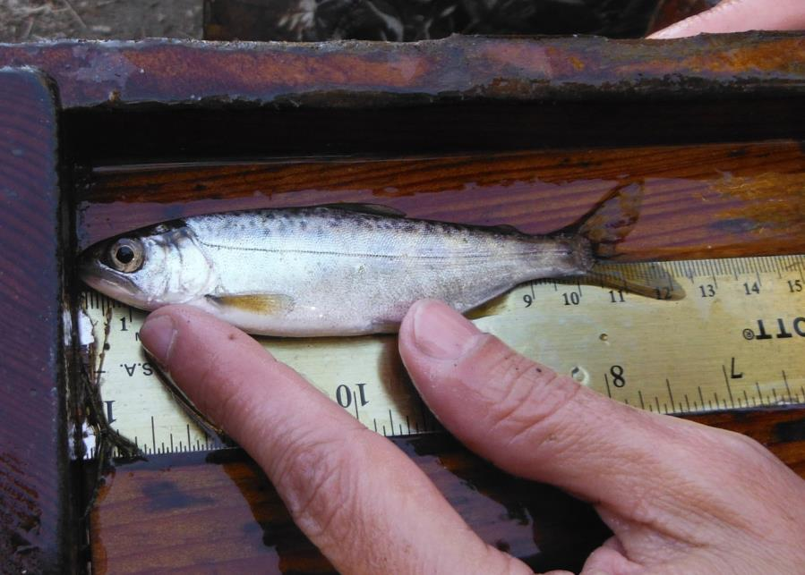

Photograph1 . Juvenile Chinook salmon (109 mm FL / 15.0 gram) captured below boulder weir at

the Putah Diversion Dam Site, 20 October 2016

The spatial distribution of exotic fishes in the lower basin also varied by species (Table 4). Black bullhead (*Ameiurus melas*), white catfish (*Ameiurus catus*) and golden shiner (*Notemigonus crysoleucas*) and common carp (*Cyprinus carpio*) were limited to single locations in the lower basin. Largemouth bass (*Micropterus salmoides*) and bluegill were widely distributed in Fall 2016 and were captured at nine and seven of the sites, respectively. While these two exotic sunfish had a relatively wide distribution, their highest densities occurred along the lower 5.5 miles of the survey area, at the 1 KM site and downstream (Table 4).

Despite the wide distribution of bluegill sunfish noted above, the continued suppression of nonnative “panfish” populations that were first observed in the 2010 surveys still appears to be continuing. This group is comprised of the smaller sunfish of the genus *Lepomis* and includes bluegill, green sunfish (*L. cyanellus*), redear sunfish (*L. microlophus*), warmouth (*L. gulosus*), and various hybrids forms. Prior to 2010, green sunfish and bluegills were among the most common species of fish found in lower Putah Creek. In the six fall surveys conducted between 2003 and 2008, “lepomids” made up 28.1 percent of the total fish captures, and averaged 1,462 lepomids per survey. In the six complete, basin-wide surveys between 2010 and 2016, lepomids had declined to only 4.4 percent of the total captured fish, and averaged only 199 lepomids per survey. This is a decline of about 86 percent in lepomids/survey from the 2003-2008 to the 2010-2015 survey periods. The scarcity of lepomids in 2012 through 2016 is especially surprising since these three water years were all classified as below normal (or less) in the Sacramento Valley with few periods of natural high flows, that might disrupt sunfish spawning. These non-native sunfish species usually thrive during these low and warm water conditions. Future surveys may show if these exotic sunfish abundances rebound to former levels, or perhaps this suite of species is finding conditions in lower Putah Creek no longer suitable to sustain abundant population levels.

Despite the recent declines in the smaller lepomid sunfish populations in lower Putah Creek, the larger centrarchids, such as the “micropterid” basses or black bass (especially largemouth bass) still remain abundant, especially in the lower 14 miles of the creek (Table 4). In the six surveys conducted from 2003 to 2008, bass (i.e., largemouth, smallmouth, and spotted bass) made up 6.8 percent of the total fish captures, and averaged 353 black bass per fall survey. In the six complete basin-wide surveys conducted from 2010 to 2016, black bass have made up 11.8 percent of the captures and have average 401 bass per survey. This is an increase of 13.6 percent in black bass per survey from the 2003-2008 and the 2010-2016 survey periods. So, while the smaller sunfish species have exhibited a decline in recent years, the basses have remained a dominant fish, especially in the downstream survey areas. Perhaps some species interactions are operating where black bass are helping to suppress the smaller sunfish in the lower basin through predation. It is unknown how the presence of black bass in the lower basin may impact the recently-resurgent Chinook fry outmigration in the winter and spring. Estimates for the fall-run Chinook salmon migration into Putah Creek were 700 adult fish in 2015 (Ken Davis, personal communication, 4 January 2016 email) and 1,500 fish in 2016 (Alvarez 2016). Snorkel surveys conducted in the winter and spring of 2016 indicated successful emergence and emigration of fry from upper basin (Salamunovich 2017). Juvenile salmon were still present even after the early April re-installation of the Los Rios irrigation flashboard dam in the Yolo Bypass area of Putah Creek. Once re-installed, the dam blocks any further emigration and creates large warm deep water pools that harbor largemouth bass.

The 2016 survey included the Winters Putah Creek Park site, which represents a relatively new sample site along lower Putah Creek that has been surveyed only since 2012. In November 2011, a channel realignment and floodplain restoration project (Winters Park Project) was completed along a 3,700 foot-long section of Putah Creek. This project was designed to restore natural channel form and function, enhance habitat of native species and improve public access in a reach that had been mined extensively for gravel and otherwise enlarged, straightened and dammed for flood conveyance and seasonal water storage.  This project included removing an historic concrete low flow barrier (Winters Percolation Dam built in 1938 [Sears 2010]), reconfiguring the creek channel to a narrower and shallower meandering form, restoring the functional floodplain, and replanting native plant species along the riparian corridor. Three existing riffles were augmented and 14 new riffles were created at 200 foot intervals by importing 2,000 tons of salmon spawning gravel mix (Rich Marovich, personal communication). It was anticipated that this channel realignment project would eliminate the extensive areas of large deep pool habitat that acted as a heat sink and harbored large predatory non-native basses, and instead create hydraulically diverse and cooler water habitat that would benefit native fish, including salmonids. Fish salvage and relocation efforts conducted in the project area in September 2011 (prior to construction) included only one rainbow trout in this section of Putah Creek (Peter Moyle, personal communication). Since channel restoration, rainbow trout have regularly been captured in this area.

In conclusion, despite continuing dry and below normal water years and limited periods of extended high flow, the native fish populations continue to thrive in the thirteen miles of Putah Creek from the Putah Diversion Dam to downstream of Pedrick Road. Continued fall fish monitoring should indicate how the fish populations respond to the changing water year types and the continuing benefits of the Accord flow regime.

**Literature Cited**

Alvarez, F. 2016. Record numbers of salmon are spawning in Putah Creek. Davis Enterprise. 28 December 2016.

California Department of Water Resources (DWR). 2016. Drought and Water Year 2016: hot and dry conditions continue. California drought update. Sacramento, CA. 8pp.

Davis, K. 2015. 2014 Putah Salmon Run. Wildlife Survey & Photo Service Report No. 4963. 6p.

Davis, K. 2016a. Putah Creek Salmon Run - 700 fish estimate. 4 January 2016 email. 700 salmon in fall winter 2015-16

Davis, K. 2016b. 2016 juvenile Chinook. 1 July 2016 email. (juv Chinook oversummer at Pickerel weir)

Kiernan, J.D., P.B. Moyle, and P.K. Crain. 2012. Restoring native fish assemblages to a regulated California stream using the natural flow regime concept. Ecological Applications 22:1472-1482.

Salamunovich, T. 2017. Late Winter and Early Spring 2016 Chinook Fry Snorkel Surveys on Lower Putah Creek. 6 January 2017 Memorandum to SCWA. 11pp.

Sears, S. 2010. Putah Creek Path: envisioning opportunities for a community. Senior Project, University of California, Davis. 66pp. [have PDF]